USER’S MANUAL

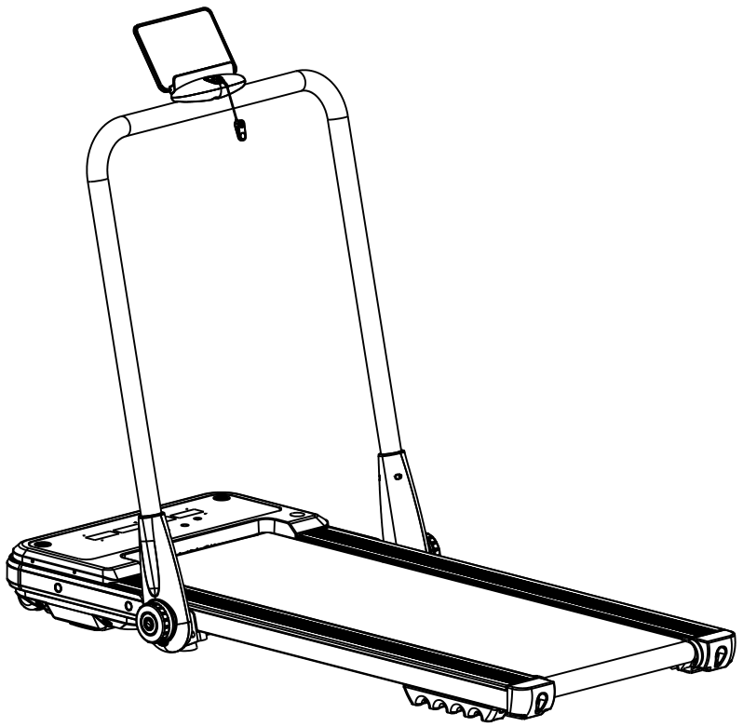

PLEASE DO NOT RETURN PRODUCT TO THE STORE.

If you have any problem or concerns, please feel free to contact our customer
service department. We will reply you as soon as possible.


E-Mail: wmcsr@comptree.net Tel: 626-912-8886 Ext.100
Contents

1.Product Brief ……………………………………….1
2.Security Precautions and Warnings ……………………………………2
3.Installation Instructions ……………………………………5
4.Routine Maintenance ……………………………….……11

1. Product Brief

Phone holder

Upright colum
Motor cover
Rotation knob

Running belt
Side rail
End cap

Main technical parameters
No. | Parameters Names | Description
1 | Input voltage | 110V~,50/60Hz
2 | Speed | 0.8-14 Km/h
3 | Running surface | 405*1100 mm
4 | Max user weight | 240LBS
5 | Expand dimensions | 1380*720*1030mm
Packing list
No. | Name | units | Qty
1 | Complete machine | Set | 1
2 | Phone holder | pc | 1
3 | Rotation knob | pc | 2
4 | Accessory bag | Set | 1
Accessory bag list
NO. | Name | QTY | NO. | Name | QTY
1 | 6# inner hexagon wrench | 1 | 4 | Silicon oil | 1
2 | Combination wrench | 1 | 5 | User manual | 1
3 | Remote | 1 | 6 | Safety key | 1
- Security Precautions and Warnings
Tip: Before folding the treadmill, make sure that the surface incline is "zero".
Please read the instructions carefully before use.
Notice:
- Indoor using and storing the walking board, avoid dampness, and can not be spilled by water.
- Please wear suitable clothes and sneakers before exercise. Prohibited to exercise on the walking board barefoot.
- High power plug must be grounded, electric outlet should have a dedicated circuit, do not share with other electrical equipment.
- Keep children away from the machine to avoid accidents.
- Avoid too long time and overload operation, otherwise will cause motor and controller damaged, and will accelerate the deterioration of bearing,walking belt and board. Should maintain machine on a regular basis.
- Keep machine away from dust to avoid strong static.
- Please cut the electric power off after using.
- Please maintain good ventilation when running.
- Please clamp security lock cable on your clothing to make sure the machine stops at emergency condition.
- If you feel not very well when using this machine, please stop and consult a doctor.
- Silicone oil must be kept away from children after use.
- If power cord is damaged, please contact our qualified maintenance personnel for service rather than disassemble it at your own discretion.
!
Forbidden
- Don't use the machine in the status of the shell break in or break off （the internal structure exposed）or under the condition of welding-parts may fall off.
---- Otherwise an accident or injury may happen.
- Don't jump up and down in the process of movement.
---- May be injuries caused by the fall.
- Don't keep machine in or near moist space such as the bathroom.
- Don’t place machine in direct sunlight, or high temperature places such as near a stove or a heating appliance .
----Otherwise may cause the leakage and burst into flames.
- Don't use when the power cord is damaged or power plug pin is loose.
----Otherwise will lead to an electric shock, short circuit or fire.
- Don't damage or bent by force or reverse the power cord. Don’t place heavy objects on machine, don't clamp the power line.
----Otherwise will cause fire or get an electric shock.
- Don't use machine for more than 2 people at the same time, and don't get close to the machine when it is in use.
---- Or it may be an accident or injury due to falls.
- People who can’t express their consciousness or can’t operate the machine by themselves cannot use the walking board.
----May occur accident or injury.
Avoid drinking water or pouring water when operation.
---- May cause electric shock and fire. Forbidden!
- People who seldom do exercise shouldn't suddenly do intense exercise.
- After eating or when feel tired, do not use machine.
---- May lead damage to your health.
- This product is suitable for family use, does not apply to schools, gymnasium and so on. ---- There is the danger of injury.
- Don’t use when hard objects are in pants pockets.
----May cause accident or injury.
- Don’t use when the power plug is on the needle, garbage, or water.
----May cause electric shock, short circuit, or fire. Do not use with wet hands!
- when not in use, pull out the power plug from the socket.
----The dust and moisture can age the insulation, and result in leakage fire.
- This appliance is not intended for use by persons (including children) with reduced physical, sensory or mental capabilities, or lack of experience and knowledge, unless they have been given supervision or instruction concerning use of the appliance by a person responsible for their safety.
- Children should be supervised to ensure that they do not play with the appliance.
Ground protection system!
!
Grounding instructions!
- This product must be grounded. If the machine is dysfunctional, grounding will provide a good channel for electric current, in order to reduce the electric shock risk.
- This product is equipped with power plug with grounding conductor and plug. Completely insert the plug to standard socket.
- If the equipment grounding conductor’s connection is improper, it will cause electric shock. If you have doubts about whether your product is grounded correct or not, please entrust professional to check.
- Please use the socket which has the same shape with the grounding plug. Don’t use plug adapter.
This appliance can be used by children aged from 8 years and above and persons with reduced physical, sensory or mental capabilities or lack of experience and knowledge if they have been given supervision or instruction concerning use of the appliance in a safe way and understand the hazards involved, children shall not play with the appliance, cleaning and user maintenance shall not be made by children without supervision.

- Installation Instructions
When installing, simple arrange all of the screws in their proper position first, then tighten the screws the treadmill frame has been positioned when the installation of frame is done.
NO. | Name | QTY
1 | Complete Machine | 1PC | 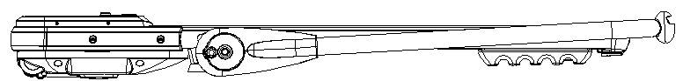
2 | 6mm inner hexagon wrench | 1PC | 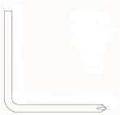
3 | Combination wrench | 1PC | 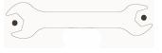
4 | Safety key | 1PC | 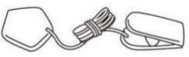
5 | Silicon oil | 1PC | 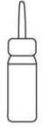
6 | Phone holder | 1PC | 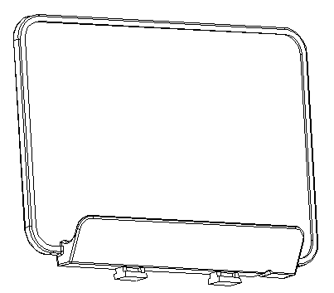
7 | Rotation knob | 1PC
8 | Remote | 1PC | 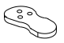
9 | User’s manual | 1PC

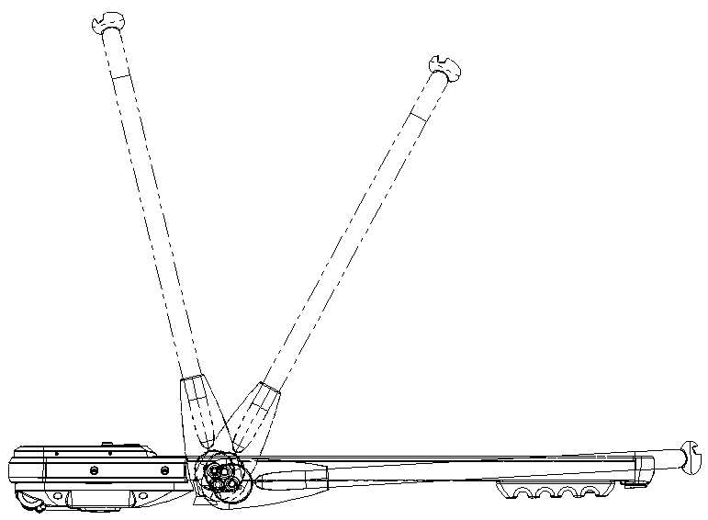
Step1.Put the machine flat on the ground. Stand the upright columns according to the direction showing in the pictures bellow.

Step2.Find the rotation knobs in the accessory bag and use them to lock the two sides of the upright columns. (Note: Please tighten with clockwise direction.)
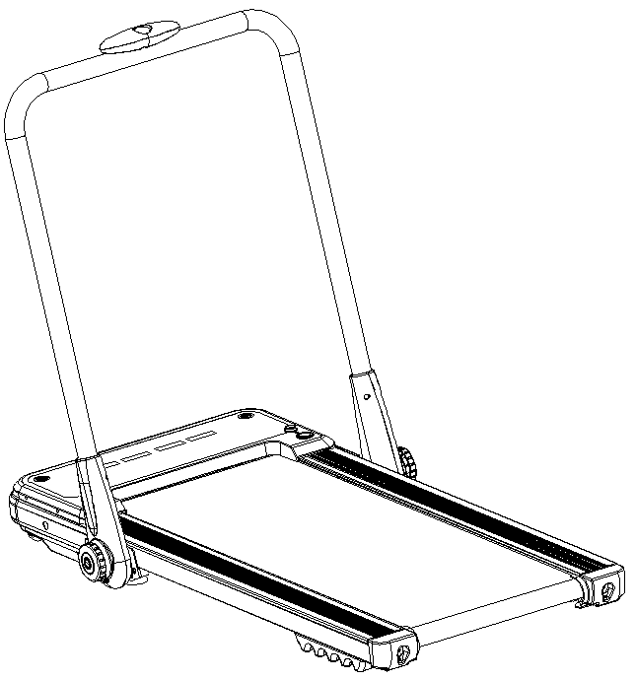
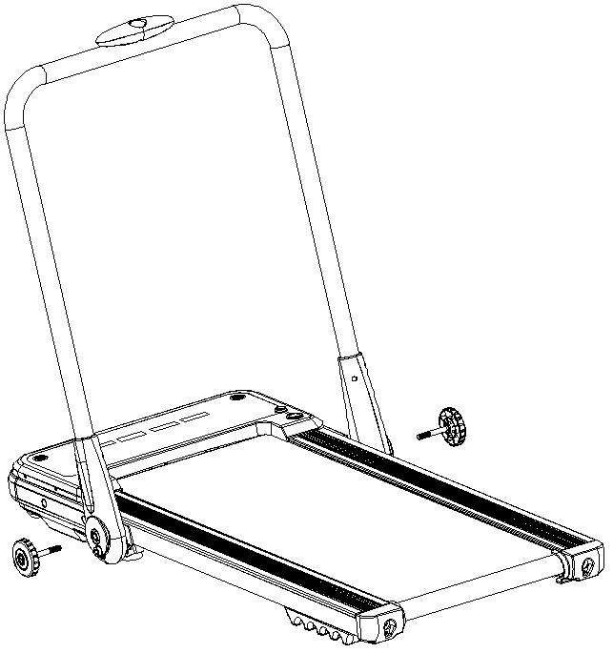

knobs

knobs

Step3.Align the Phone holder ‘A’with gap‘B’(P1) and install the phone holder（‘C’）(P3).Push the Phone holder in the arrow direction. When you hear a click, the phone holder is installed(P4).
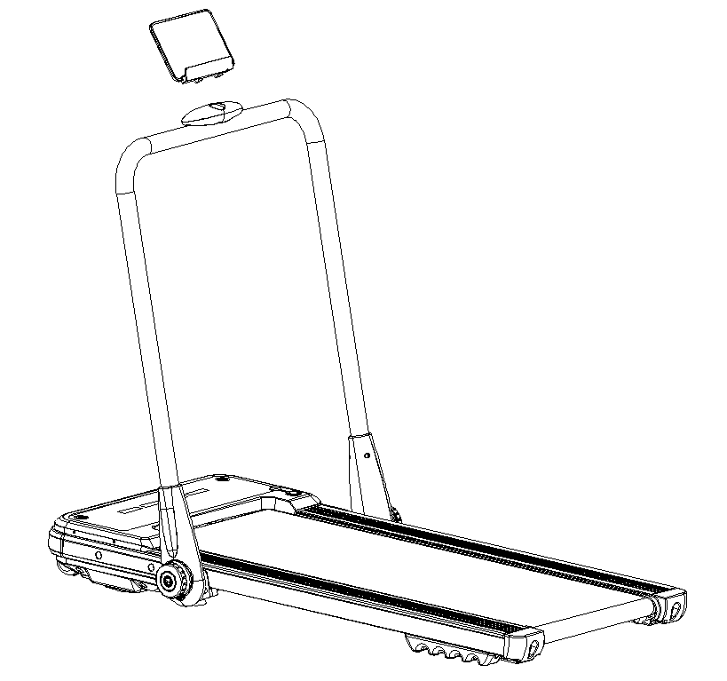
P1
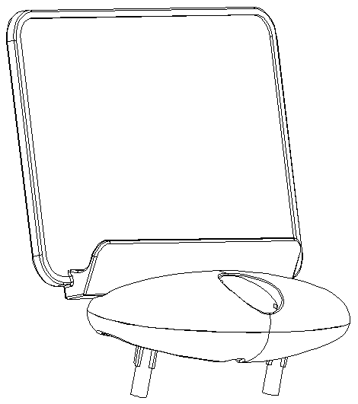
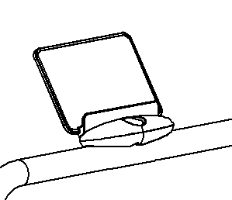
P2
P4
Phone holder
P3

A

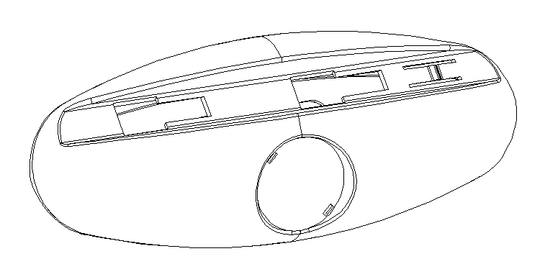
C
B

Step 4. Put the safety key on the yellow circle on the console (as shown below). Press the start button to turn on the treadmill. (Notice: The treadmill only starts when the safety key is attached to the yellow circle on the console.)
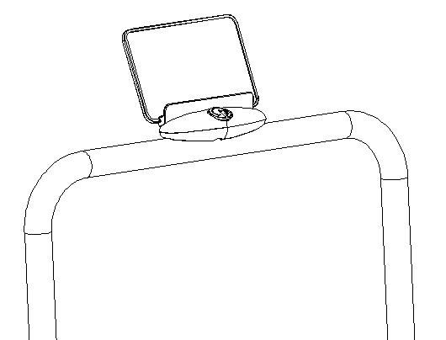
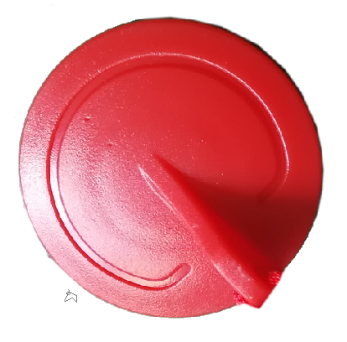

The safety key is in red color. Please find it in the
accessory bag.

NOTE: after you have finished putting the treadmill together, make sure that all screws are
installed in their appropriate place according to the previous steps. Please be sure all parts are
properly locked in and secured by screws before plugging in electricity.

Using walking board
1. Insert the power plug properly and turn on the switch(in red color)(1). When the light is on, there will be a beep sound. (Note: The switch is on the right side of the machine.)
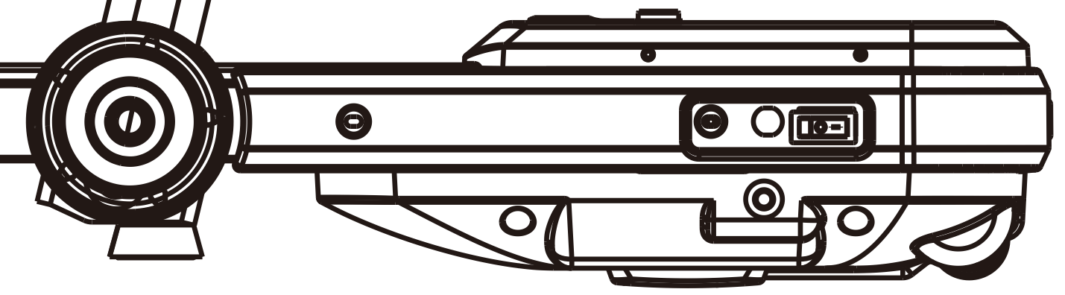
1

- Folding instruction
Fold the walking walking board to save your space. Please turn off the switch and unplug the power line before folding.
- Loosen(counter clockwise direction) the two knobs on both sides.
- Lower the upright columns gradually until they are of same level with the walking deck.
(Notice: In case of the break of storage holder, it is suggested to remove it and store it properly after folding.)

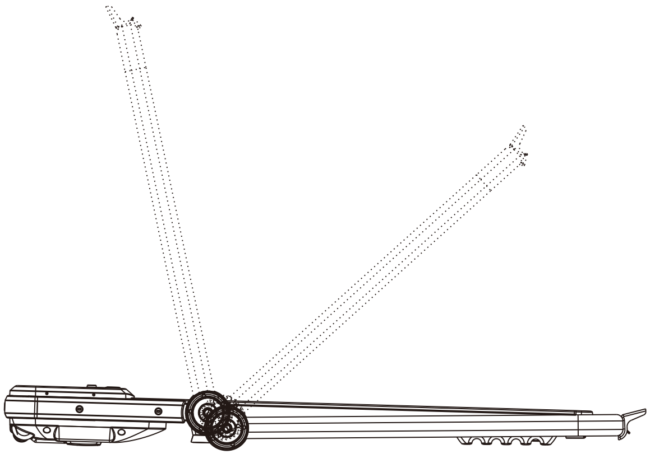
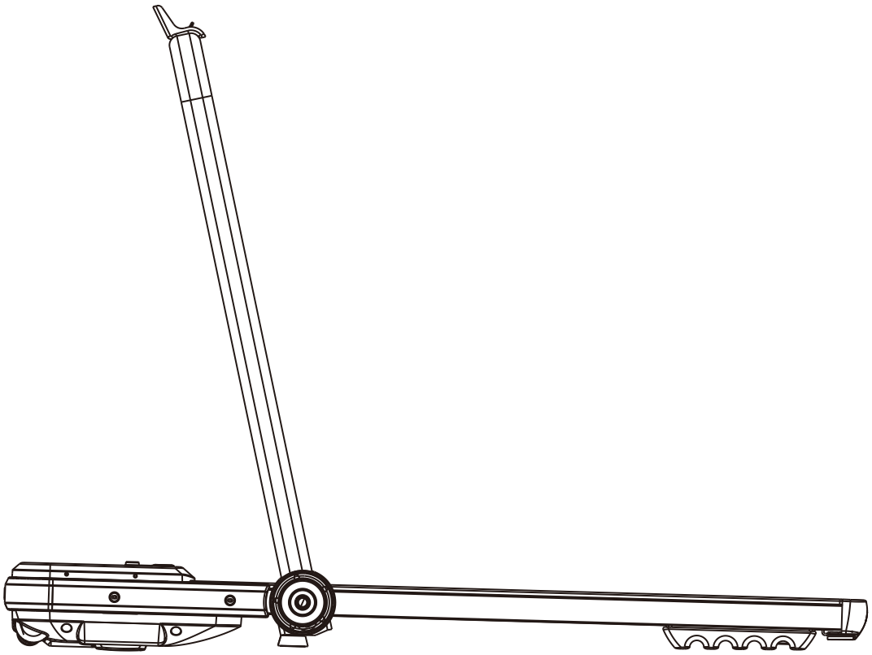

Tight: Clockwise
Loose: Counter clockwise

- Screen display

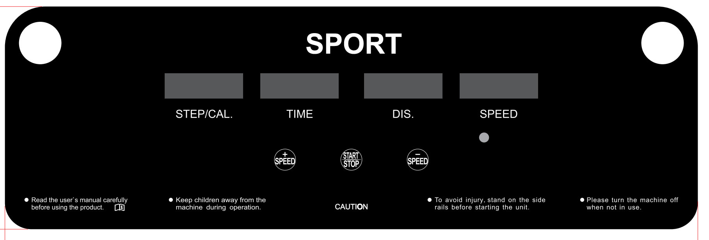

- Display Function
4.1 LED window display
Steps Display: Display the current steps.
Calorie display:Display the current calorie.
Time Display:Display the current time.
Distance display:Display the current distance.
Speed display: Display the current speed.

4.2 Control button function
Start/Stop: In stop state, press this button to start the walking board.
In running state, press this button to stop the waling board.
Speed+: In running state, press this button to increase the speed.
Speed-: In running state, press this button to decrease the speed.

Start Instructions
  - Manual mode instruction
    - Turn the switch on, you will hear a beep sound and the machine enters manual mode.
    - Press Start/Stop button, the screen will display numbers and the walking board starts running.

  - Bluetooth App Control (According to the actual configuration)
Use mobile phone app to control the walking board.
Use phone to scan the QR code bellow to download the app.


  - Infrared Remote Control ( According to actual configuration)
When the power is on, long press the start/stop button on the remote for around 7 seconds to match with the machine(continuous beep sound indicates the success of matching. If there is no beep sound, it means the matching is not done.). After matching, the remote can be used to control the walking board. Press the Start/Stop, Speed+, Speed- to control the walking board.

Sleep Mode
The system is with energy saving function(sleep mode). If there is no control command in 10 mins, the system will enter energy saving mode and the screen stops displaying. Press any button can awaken the the system.

Translation of Error Codes
Error code | Description | Solution
E1 | Communication Abnormal: when the power is on, the connection between lower controller and the console is abnormal. | Possible Cause:  The communication between the lower controller and console is blocked, check each joints between the controller and console, ensure that each core is fully plugged in. Check the the connection line, replace it if it’s damaged.
E2 | No signal from motor. | Possible Cause:  Check the motor cable to see whether it is connected well or not, if not, connect the motor wire again.  Check the motor cable to see whether it is damaged or has a burnt smell, if yes, replace the motor.  Check the speed sensor to see whether it is correctly installed or damaged
E5 | Over current protection:  In working , the lower controller detects the current to be over 6A for more than 3 seconds. | Possible Cause:  Overloading leads to excessive current, and the system stops out of self-protection, or some part is stuck, causing the motor to stop. Adjust the walking board and restart it. Check if there is liquid or burnt smell while the motor is running, if yes, replace the motor; check if the controller has a burned smell, if yes, replace the controller; check the power supply voltage, if it does not match the specifications, change into correct voltage and test the machine again.
E6 | Explosion-proof impact protection: the abnormal voltage or motor cause the faulty of circuit that drive the motor. | Possible Cause:  Check if the power supply voltage is 50% lower than normal voltage ，use the correct voltage and test the machine again；check if the controller has a burnt smell and replace the controller; Check if the motor cable is connected and connect the motor wire again.

5. Routine maintenance
Warning: Before cleaning or maintaining products, please be sure the power plug of the walking board is pulled out.
Cleaning: Comprehensive cleaning will extend the using life of the electric walking board.
Remove dust periodically in order to keep the parts clean. Be sure to clean walking belt with both sides of the exposed portion, which will reduce the accumulation of impurities. Make sure to wear clean athletic shoes to avoid carrying the dirty matters into running board and belt. walking board belts shall be cleaned by a damp cloth with soap. And please pay attention to avoid to wet the electrical components and walking belt.
Warning:Make sure power plug disconnect before moving motor cover away, clean the motor at least once a year.
Running belt specialized lubricant
This walking board’s deck and walking belt has been lubricated in factory. Friction between the walking belt and deck has a great influence to the using life and the performance of the walking board, therefore regular applying of lubricant is needed. We advise you to check the board regularly. If the board’s surface is damaged, please contact our customer service center.
We advise using lubricant between walking belt and running board with following schedule:
Lightweight user (use less than 3 hours a week) once per month;
Heavyweight use (use more than 7 hours a week) once every half month.
1.In order to better safeguard your electric walking board and extend the life of the machine, it is recommended that after your continued use of two hours, turn off the machine and let it rest for 10 minutes before using again.
2.If the walking board belt is too loose, there will be skid phenomenons while using; if it’s too tight, it may reduces motor performance and harden the abrasion of roller and the walking belt. You can lift two sides of the walking belt for 50-75mm when the tightness is appropriate.
Running with adjusted alignment and tightness
In order to better use the walking board and make the walking board functions work better, it is necessary for you to adjust the walking belt into the best condition.
Running Belt alignment
- Put walking board flat on the ground.
- Make the walking board run at a speed of about 6-8km/hour.
- If the walking belt is closer to the right, rotate the right adjusting bolt with 1/2 turn counter-clockwise, then rotate the left adjusting bolt with 1/2 turn clockwise. (Picture B)
- If the walking belt is closer to the left, rotate the left adjusting bolt with 1/2 turn counter-clockwise, then rotate the right adjusting bolt with 1/2 turn clockwise. (Picture A)
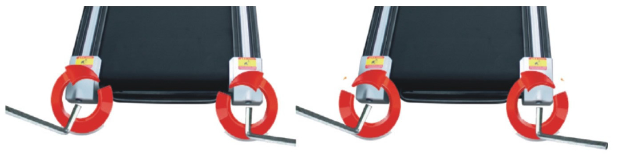
Picture A Picture B

Applying silicone oil
Step 1: Use scissors to cut the upper end of the oil bottle (Picture 1).
.
Step 2: Uncover the oil tank cover located on the motor cover(Picture 2 and 3).
Step 3: Squeeze the silicone oil into the oil tank(Picture 4).
Step 4: Start the walking board, adjust the speed to 5-6 km/h, and run for 5 minutes to make the oil evenly distributed on the walking belt.
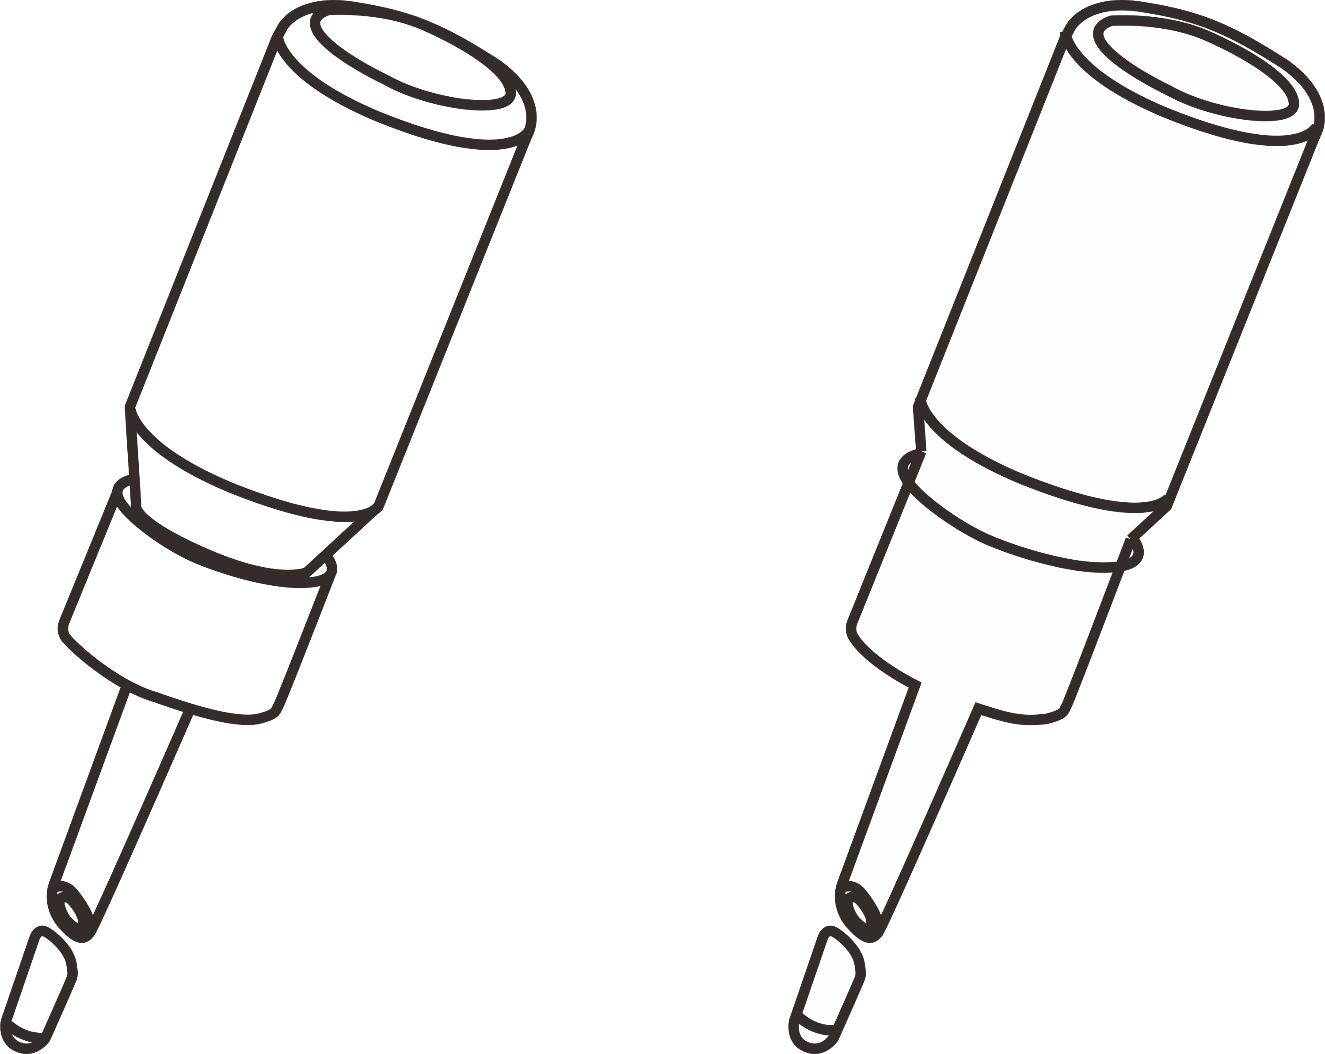
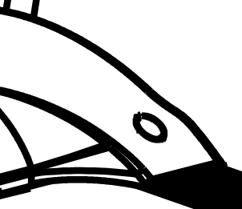
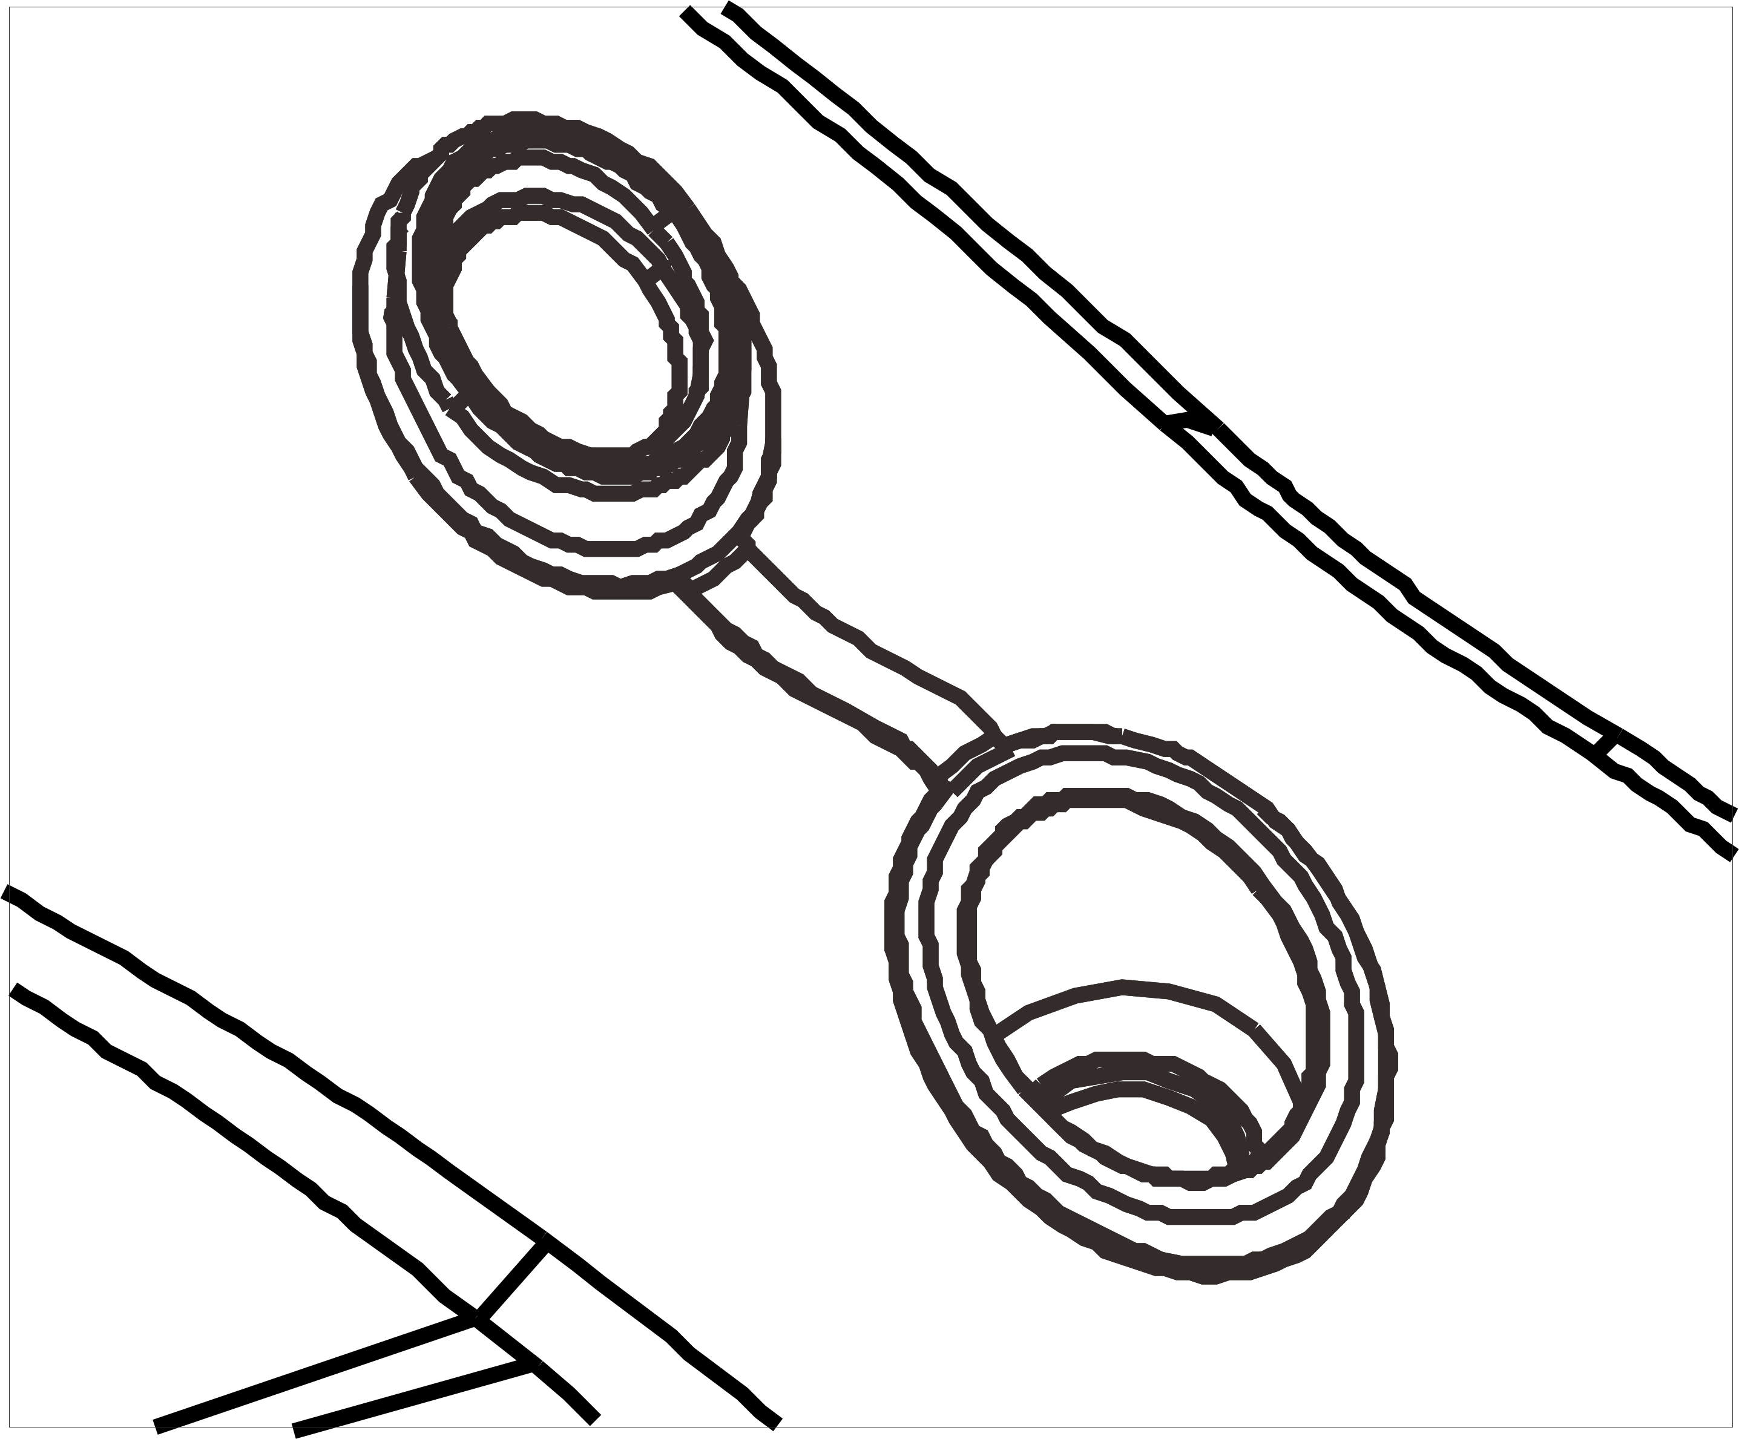

Picture 1 Picture 2 Picture 3 Picture 4

